**Procedure - Prepare USB and Sync USB for Windows 10 deployments**

This procedure describes how to create a new USB stick for Windows 10 Deployments and how to sync the usb image with the latest version.

After syncing a USB the stick can be used for 30 days. After this you will need to sync your USB image again.

# Create bootable USB

Prereq: Rufus tool and ISO Windows 10

* Start Rufus

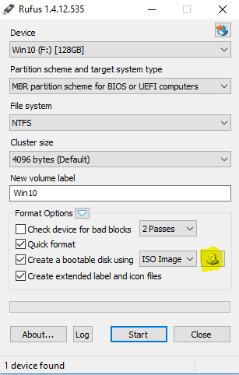

Click on the ISO image

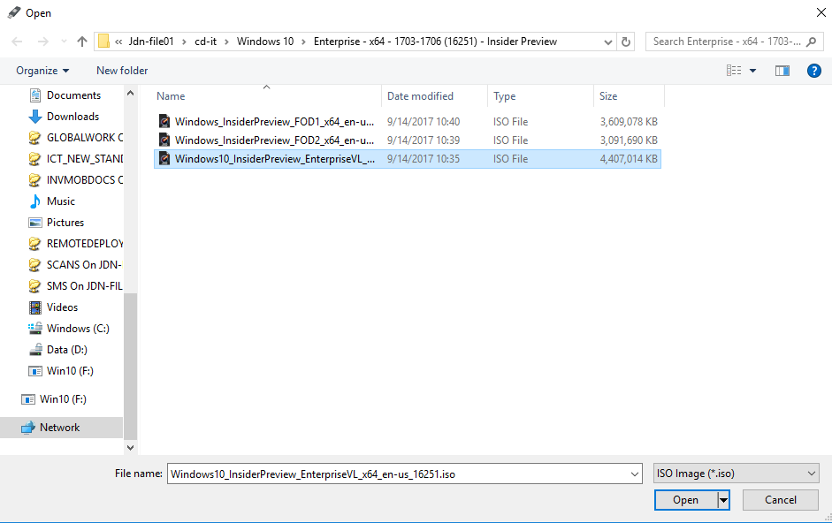

Select the Windows10.iso file

Change volume name to > ICT_WIN10

Make sure you have selected ‘MBR Partition Scheme for BIOS or UEFI computers’

Click Start

>> this process will create a large bootable USB

Note: After this process you DO NOT HAVE the JDN image yet > follow the Sync USB step

# Sync USB with JDN image

Go to \\jdn-file01\osdeployment$\USB_STICK

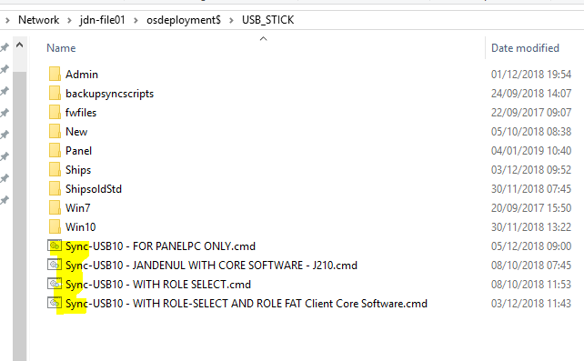

Doubleclick 1 of the Sync-USB10 jobs depending on the USB you want to create

## Sync-USB10 – FOR PANELPC ONLY.cmd

This job will create a USB image that can only be used on Panel PC’s (VERSO)

## Sync-USB10 – JANDENUL WITH CORE SOFTWARE – J210.cmd

This job will create a USB image for JANDENUL.COM pc’s (used during JUMP2TEN). A Part of the core software of jandenul.com domain pc’s are pre-installed already, the AD computer-object and the Altiris object of the computer are re-used

This can only be used for RE-INSTALLATION of pc or Jump to Windows 10.

## SYNC-USB10 – WITH ROLE SELECT.cmd

This job will create a USB image for Windows 10 installation. No core software installation is executed. After windows 10 installation, you will get a screen where you can select the role of the pc.

## SYNC-WITH ROLE SELECT AND ROLE FAT Client Software.cmd

This job will create a USB image for Windows 10. The CORE software of a Ship’s computer role is pre-installed already, you will still need to select the Ships Role!

This procedure describes how to use the JDN USB to install/re-install your windows 10 on your pc.

1. Power Off your device
2. Plugin the JDN USB
3. Start your device and quickly press several times on F9 to get the boot Menu

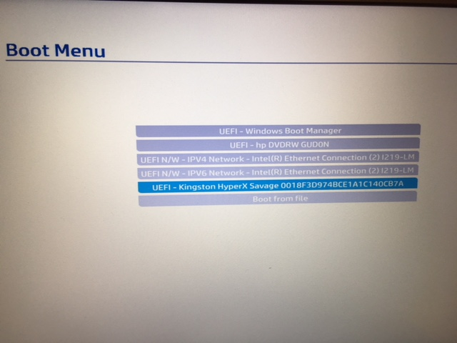

1. Select the one with “...Kingston HyperX...” and click enter

Your device will now the WINPE environment (= this is a pre-windows environment where we will prepare your machine for the windows 10 installation)

You only need to provide wich Keyboard Layout your device has and a computername > check the red label on your device to get the JDN-xxxxx number

Attention the keyboard layout in the WinPe environment is always Querty, so be aware of the computername

Note: in most case the computername is injected into the bios and read-out from during preparation.

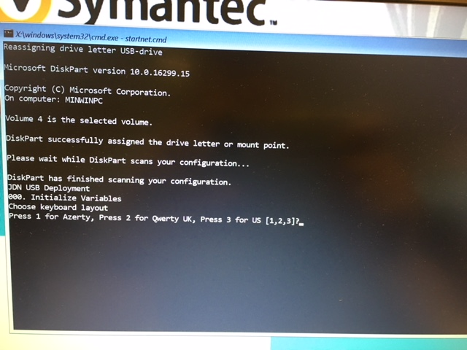

1. Press 1 for Azerty or Press 2 for Querty UK or Press 3 for Querty US

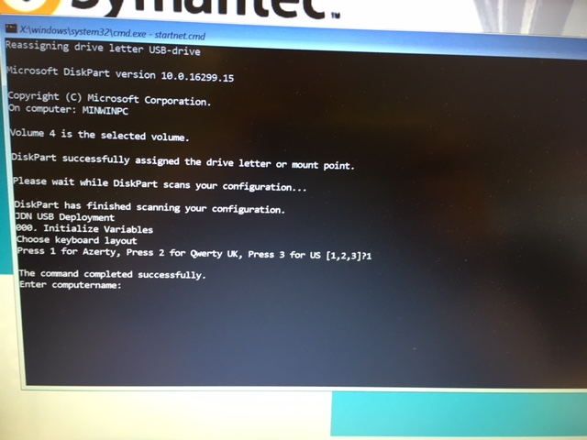

1. Provide the computername > JDN-xxxxx

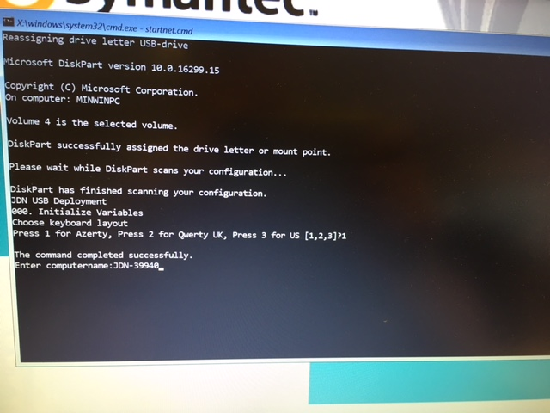

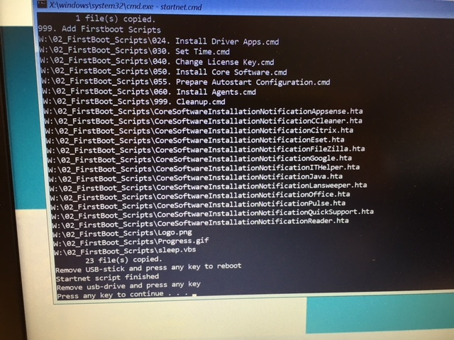

Wait till you get the message ‘Remove usb-drive and press any key” (it takes about 10 minutes for the USB to prepare your machine)

1. Remove the USB from the device and press any key. After that your device will reboot into Windows and starts configuring the Operating System.

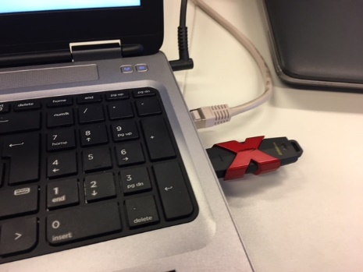 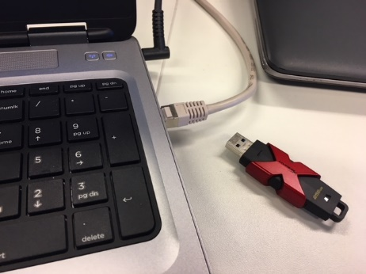

1. Do not touch the device / do not power off the device / do not click on any window when your device is in configuring state

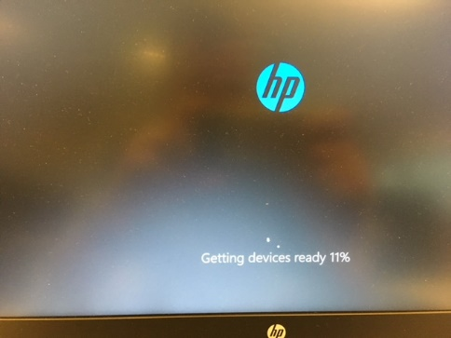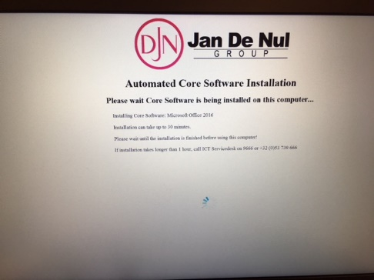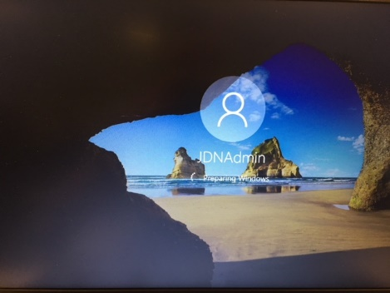

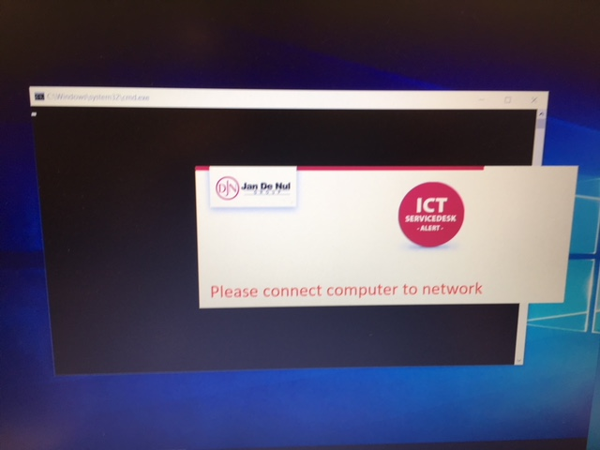

1. When your device receives the above window > make sure your device is connected with a network cable / change the network cable with another one > every 10 seconds the process will check your connectivity again and will disappear when network is found and it will continue its process automatically.

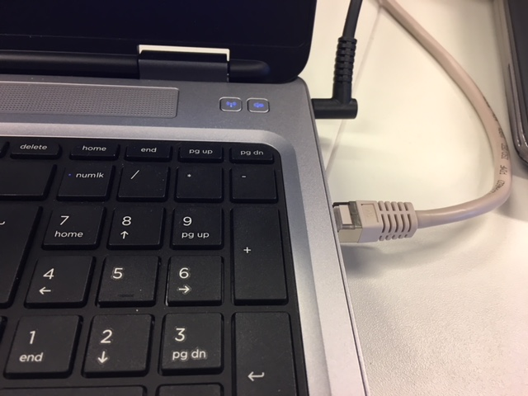

1. Do not touch your device / Do not power off your device when configuring process is being executed

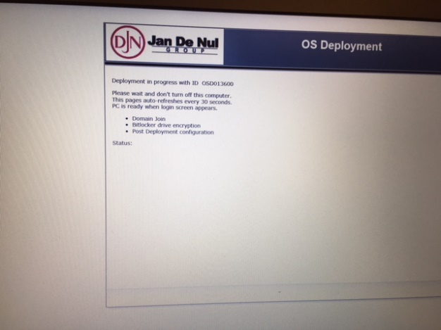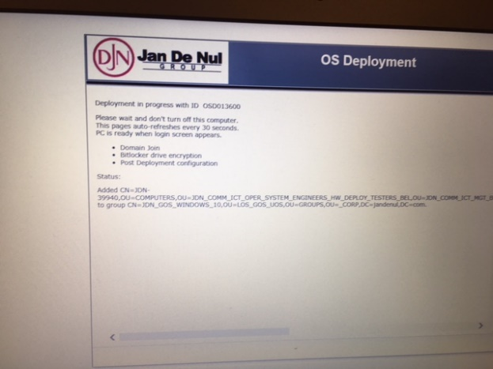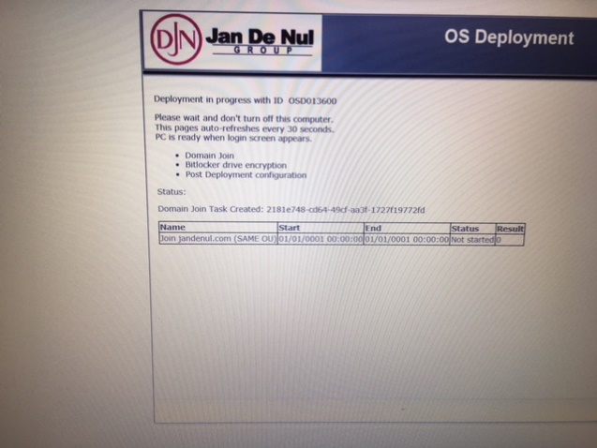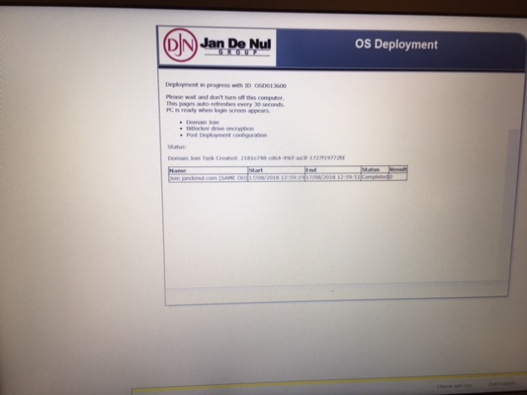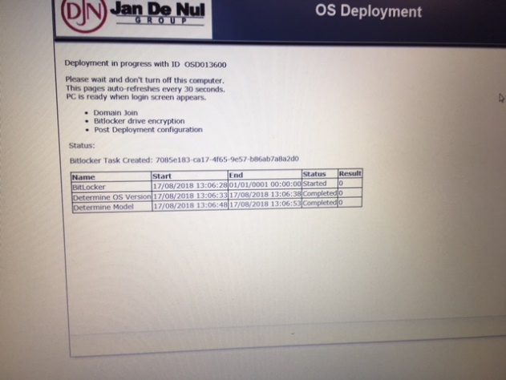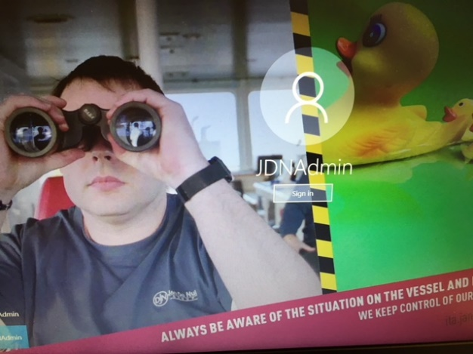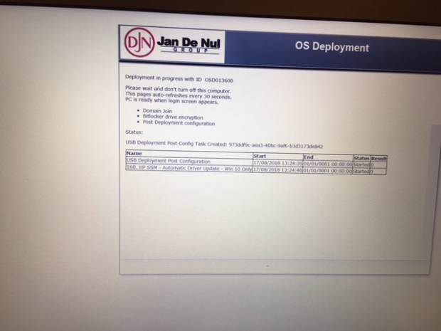

During this process your device will join the jandenul.com domain / bitlock it’s drives / execute some post configuration jobs / disable autologon

1. Your device is ready when your able to provide a password again at the Windows Logon. Here you can change the username ‘JDNAdmin’ and login with your own account.



Follow up the Deployment Flow to be sure the deployment has finished correctly

* <http://vm-alt-wf01.jandenul.com/osdeploymentstatus>

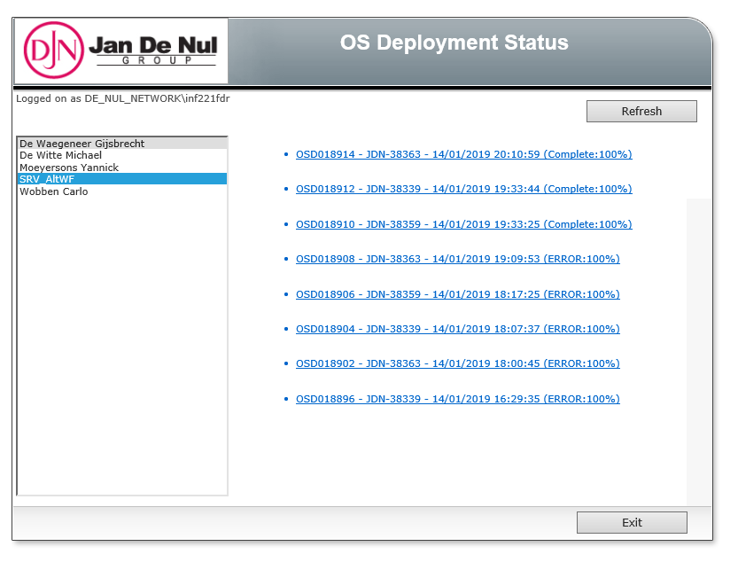

Select SRV_AltWF and at the right you will get an overview of the machines where the flow has been started. For details click on the link.

Workarounds

When after the BIOS upgrade your device doesn’t boot into windows anymore and you get an error the harddisk cannot be found. Check the BIOS if the mode is still in UEFI and not legacy mode

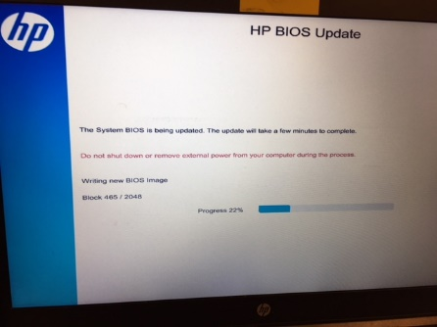 BIOS upgrade process

1. Boot your device and press several times on F10 to get into the BIOS Setup, provide the BIOS password to get the bios information. Go to the tab ‘Advanced’ > ‘Boot Options’

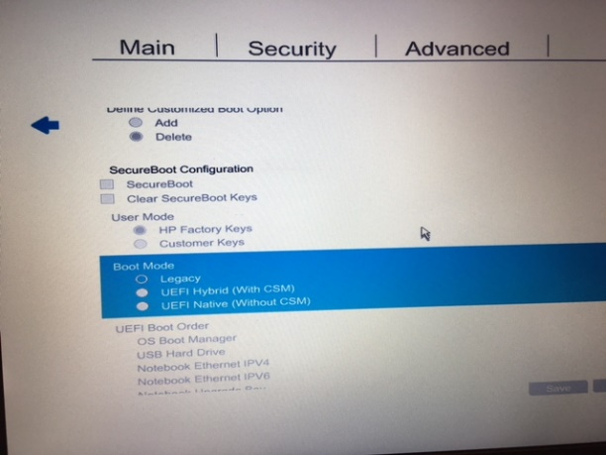

1. Go to ‘Boot Mode’ and if Legacy is selected > click enter and change it into ‘UEFI Native’ mode

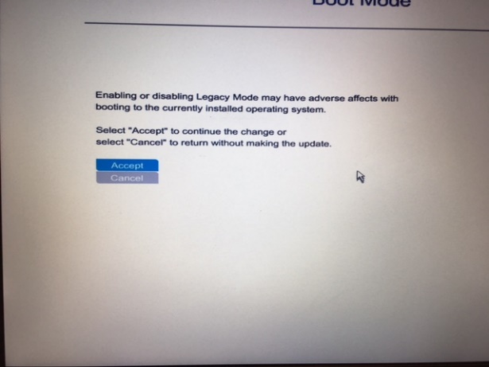

1. Accept the modification

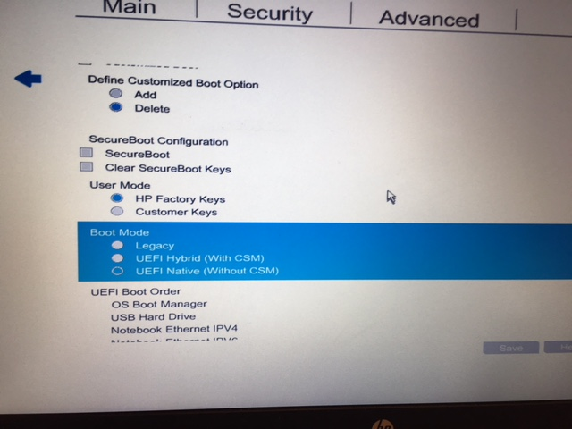

1. Check that UEFI Native mode is now selected

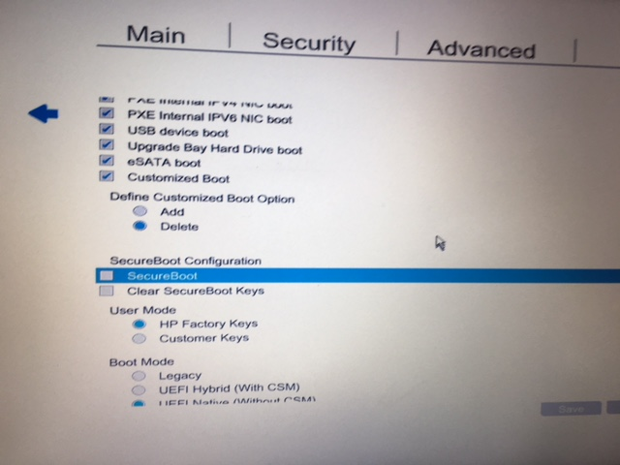

1. Go to ‘Secure Boot’ and select the option by clicking on enter

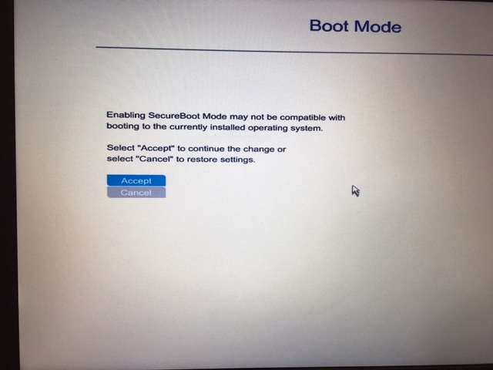

1. Accept the modification

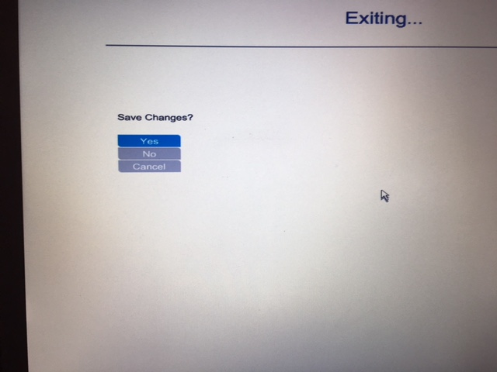

1. Press several times ESC to quit the BIOS > Save your changes by selecting YES

Now your machine will boot again to Windows 10.